Task: Data Analysis

**1A. In what city Fond Rouge loses the highest % revenue due to returns?**(Where the ratio refund:revenue is the highest?)

Ans: San Diego

**1B. Paste a screenshot of your Stacked Bar chart of Revenue & Refund per US city.**

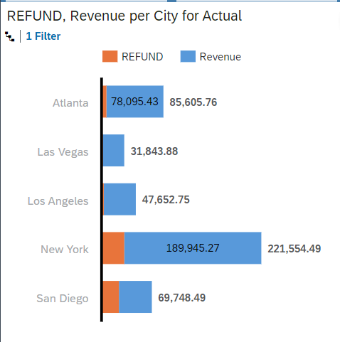

**2A. What is the % NEG Class-ifiers in the US?**  
((Number of all sales with Sentiment Class=NEG in the US) / (Number of all sales in the US) * 100)

Ans: 30.99%

**2B. Paste a screenshot of your Donut chart of Sentiment Class in the US**

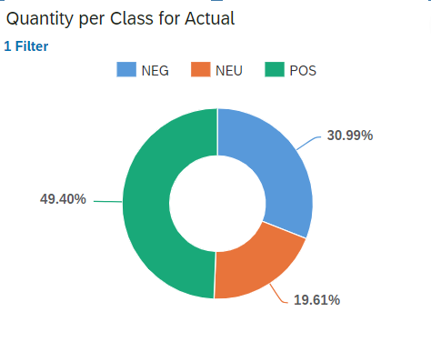

**3A. What is the % NEG Class-ifiers, Globally?**  
((Number of all sales with Sentiment Class=NEG) / (Number of all sales) * 100)

Ans. 4.25%

**3B. Paste a screenshot of your Donut chart of Sentiment Class, Globally.**

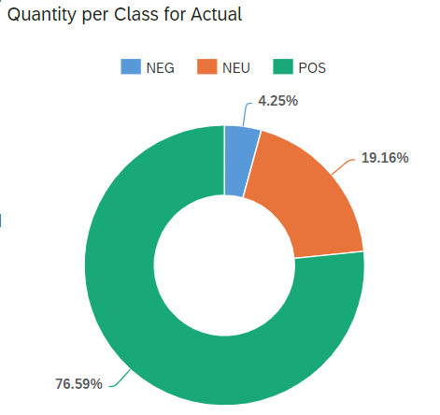

**4A. List the locations where counterfeiting may be happening?**(Hint: look for cities where the returns are lower than 20%, but the Sentiment is low (under 65))

Ans. Los Angeles, Las Vegas in the US

**4B. Paste a screenshot of your Column & Line chart of Refund/Revenue & Avg Sentiment per US city.**

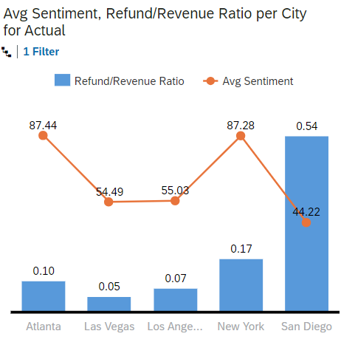

**5. Does Fond Rouge have a problem in all of its American locations? How can you tell?**

Ans. No, because places like Atlanta and New York have less than 20% of return/revenue ratio and their Avg. sentiment score is above 85 whereas location San Diego has more returns with less sentiment and LA and Vegas despite having less returns suffer with less than 65 avg sentiment score.

**6. Is counterfeit the only problem that’s observable in Fond Rouge’s data for its US operation? Why?**

Ans. Counterfeit is not the only problem, however, despite having low returns in Atlanta and New York, its important to investigate other reasons for customer dissatisfaction.

**7. Paste a screenshot of your GeoMap (Bubble Layer) of Location, Avg Sentiment, Revenue.**

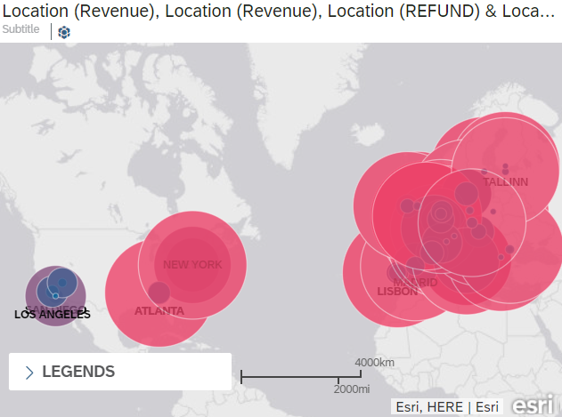

**8. Paste the login url for your SAP Analytics Cloud tenant.**(If you are logged in SAC – just copy & paste your browser url, no matter where in SAC you currently are)

**Ans. https://sactrial-saceu20-q7qwsz7o5eoliiqsmiwonv8i.eu20.hcs.cloud.sap/sap/fpa/ui/app.html#/story&/s/6D18B783C721179E58705A73F1AAFA09/?isInternal=true&mode=edit**